CSE423 - Computer Graphics (Spring-25)

Assignment (Midterm) [last updated: 13 March]
Deadline: 18 March, 2025, 11:55 PM.
Submission: In google form (link will be shared in discord)

How does a computer transform a 3D model into 2D images? State each stage of this process.

A GPU can process 80,000 pixels per millisecond. If the frame time at 30 FPS is approximately 33.33 milliseconds, estimate the maximum number of pixels that can be rendered per frame.

Given a screen resolution of 2560 x 1440 and a frame rate of 45 FPS, calculate the total number of pixels processed per second.
- Suppose, a line segment starts at (-120, 23) and ends at (-423, -423). If we draw this problem using the DDA algorithm, determine the number of times y will be increased.
- Using the Digital Differential Analyzer (DDA) algorithm find out the pixels between the lines whose endpoints are given:
  - (13,10) to (5,6)
  - (0,0) to (4,6)
  - (4,-8) to (-1,7)
  - (14,-8) to (0,4)
  - (5,6) to (8,12)
- Which problem still persists in the DDA algorithm and how was it solved later?
- There is a line with the equation, y = -5x - 20. The line segment starts from where it cuts the y-axis and ends at where it cuts the x-axis. Find the first 8 pixels using the DDA Algorithm.
- Why is the value of y incremented/decremented by 1 instead of x, when the gradient is < -1 or > 1?
- Suppose a line segment starts from P (s , r) and ends at Q (m , n). This line segment falls in Zone 1. Given that s < m and r < n, derive the formulas for determining the pixels' coordinates if DDA Algorithm is used.
- Using the Midpoint Line Drawing Algorithm and 8 Way Symmetry, find the first 6 missing pixel values starting from: (Show the present value of d as well as Δs at each stage.)
  - (20,10) to (30,18)
  - (0,-14) to (-45,11)
  - (-1,-2) to (-15,82)
  - (-18,11) to (0,-3)
  - (5,10) to (-20,5)

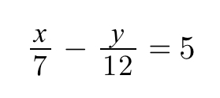
- Suppose a line segment has the equation above, and the starting point is at y = 12 and the ending point is at y = 0. Find the first 6 pixels using the Midpoint Line Algorithm.
- Describe the significance of 8 Way Symmetry in the Midpoint Line Algorithm.
- A line segment has the following orientation.
Derive starting/initial deviation (‘d’) and its derivatives (Δs)/decision parameters using mid-point line drawing algorithm.
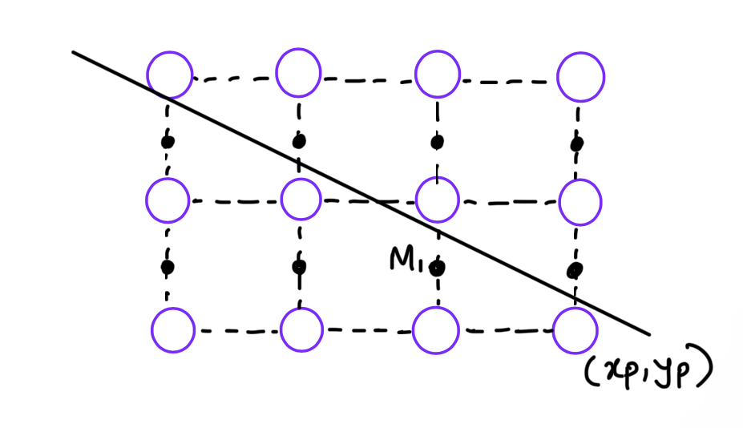
- Do you think the Mid Point Line Drawing Algorithm is better than DDA? Provide reasoning.
- Given (-30,-30) and (30, 30) are the corners of the clip rectangle. The endpoints of a line are given as (35, 37) and (-38, -20). Using the Cohen-Sutherland line clipping algorithm, identify whether the lines are Accepted, Rejected, or Partial (partially accepted) only from the outcodes. Does Cyrus-Beck line clipping algorithm produce the same output?
- Given (0,0) and (400, 300) are the corners of the clip rectangle. The endpoints of a line are given as (−50, 350) and (450, 350). Using the Cohen-Sutherland line clipping algorithm, identify whether the lines are Accepted, Rejected, or Partial (partially accepted) only from the outcodes. Does Cyrus-Beck line clipping algorithm produce the same output?
- A clipping window is 70 units wide and 30 units tall, and has its center at (0, 35). The endpoints of a line segment are (-45, 65) and (23, -10). Apply Cohen-Sutherland Algorithm, and identify whether the line is "partially inside", "completely inside", or "completely outside". If it is the first case, run the algorithm to calculate new endpoints for the line segment so that it is inside the clipping window. Does Cyrus-Beck line clipping algorithm produce the same output?
- What is 2D Region Outcode and 3D Region Outcode?
- What is the disadvantages of Cohen-Sutherland line clipping algorithm?
- Which algorithm is suitable for polygonal or circular clipping region?
- Given a line segment from (10, 60) to (25, 30). Construct the parametric equation P(t) of the line. Using the parametric equation determine the coordinates of the point where, t = 3/5.
- Does Cyrus-Beck algorithm work for both Concave and Convex polygonal region? Explain why or why not with figure.
- For the following value of t_{E} and t_{L}, comment whether the following lines are accepted, rejected or partially clipped:
t_{E} | t_{L} | Comments
0.3 | 0.7
-0.3 | 1.2
-0.3 | -0.33
-0.5 | 0.5
1.1 | 2.4
0.3 | 1.3
- Define a homogeneous coordinate system. Why does computer graphics prefer a homogeneous coordinate system?
- Determine the coordinate of a 3D point P(100, -60, 80) after rotating 60⁰ across the Z-axis, given that the center of rotation is (50, 20, 45).
- Find the following composite transformation matrices as instructed:
  - A 3D rotation of 90⁰ clockwise about the y-axis with respect to the point (a, b, c) followed by a translation of (a, b, c).
  - A reflection about the line ax - by + c = 0 followed by a scaling “e” times with respect to the point (a, b). \
  - A 3D rotation of 45º counterclockwise about the z-axis with respect to point (d, e, f) followed by a uniform scaling of factor 3 with respect to point (d, e, f) and lastly followed by a translation of (a, b, c). [Here a, b, c, d, e, f are arbitrary values]
NB. The inverse of a composite transformation matrix is each of the individual matrices inversed and multiplied in the reverse order. E.g.
